# Data Centric RAD

## Lab 3 MySQL Review II

* Get superheroes_wk3.sql from Moodle.
* Import it into MySQL described in Lab 1.
* use superheroes;
* Use the show create table <table name> command to find out the structure of the superhero_table, and list the Primary Key(s) and Foreign Key(s).
* Use the show create table <table name> command to find out the structure of the superhero_city_table, and list the Primary Key(s) and Foreign Key(s).
* Delete *Spiderman* from the superhero_table.

What happens and why?

* Insert a new superhero in the *superhero_table* as follows:

Name = ‘Joker’

real_first_name = ‘John’

real_surname = ‘Jones’

dob = 1966-07-12

powers = 22

* Delete the superhero *Joker* from the *superhero_table*.

What happens and why?

* Delete the *superhero_city_table* as follows:



* Create a new table called *city_table* as follows:

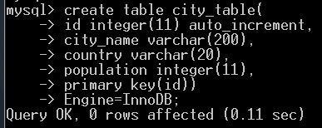

Populate it with the following data:

|  |  |  |
| --- | --- | --- |
| **Name** | **Country** | **Population** |
| Galway | Ireland | 75,000 |
| Gotham City | USA | 15,000,000 |
| Metropolis | USA | 22,250,000 |
| New York | USA | 8,500,000 |
| Springfield | USA | 20,000 |

* Recreate the superhero_city_table, this time with two columns:
  + *name* which is a Foreign Key referring to the name column in the superhero_table.
  + *city* which is a Foreign Key referring to the *id* column in the city_table.

HINT: A Foreign Key is created using the following syntax:

**Foreign Key(***column***) References** *table_name* **(***column_in_referenced_table***)**.

* + Primary Key is (name, city)
* Populate the superhero_city_table so that the following are associated:

|  |  |
| --- | --- |
| Spiderman | New York |
| Superman | Metropolis |
| Batman | Gotham City |
| Spiderman | Metropolis |
| Batman | Metropolis |
| Batgirl | Gotham City |
| Radioactiveman | Springfield |

* Delete *Galway* from city_table.

What happens and why?

* Delete *Metropolis* from city_table.

What happens and why?

* Alter the city_table as follows:

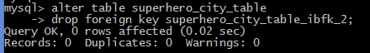

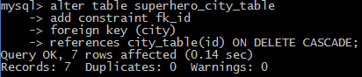

* Delete *Metropolis* from city_table.

What happens and why?